**DAILY ONLINE ACTIVITIES SUMMARY**

|  |  |  |  |  |  |  |  |  |
| --- | --- | --- | --- | --- | --- | --- | --- | --- |
| **Date:** | **04-06-2020** | | | | | **Name:** | **Shiza Amreen.J** | |
| **Sem & Sec** | **4th sem Bsec** | | | | | **USN:** | **4AL18CS078** | |
| **Online Test Summary** | | | | | | | | |
| **Subject** | | **Microcontrollers and Embedded System** | | | | | | |
| **Max. Marks** | | **20** | | **Score** | | | **13** | |
| **Certification Course Summary** | | | | | | | | |
| **Course** | **Game Development using PyGames** | | | | | | | |
| **Certificate Provider** | | | **GUVI** | | **Duration** | | | **3 hours** |
| **Coding Challenges** | | | | | | | | |
| **Problem Statement:**   1. **write a java program to read three integer values from the keyboard and find the sum of the values. Declare a variable "sum" of type int and store the result in it.** 2. [**Write a C++ program to find the missing number in array**](https://github.com/orgs/alvas-education-foundation/teams/2nd-year/discussions/99) | | | | | | | | |
| **Status: completed** | | | | | | | | |
| **Uploaded the report in Github** | | | | | **yes** | | | |
| **If yes Repository name** | | | | | **Lockdown_Coding** | | | |
| **Uploaded the report in slack** | | | | | **yes** | | | |

Online Test Details:

Today we had MES IA-3, I have attended the test and got 13 out of 20.

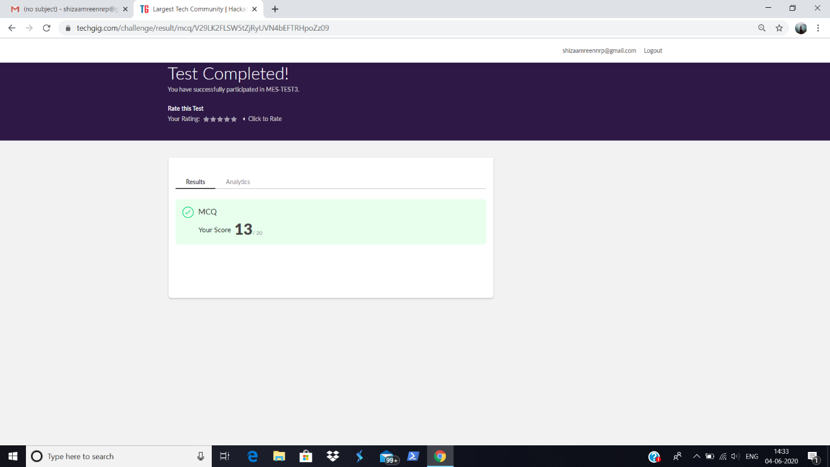

Certification Course Details:

Today I have taken the course, Game Development using PyGames, from GUVI.

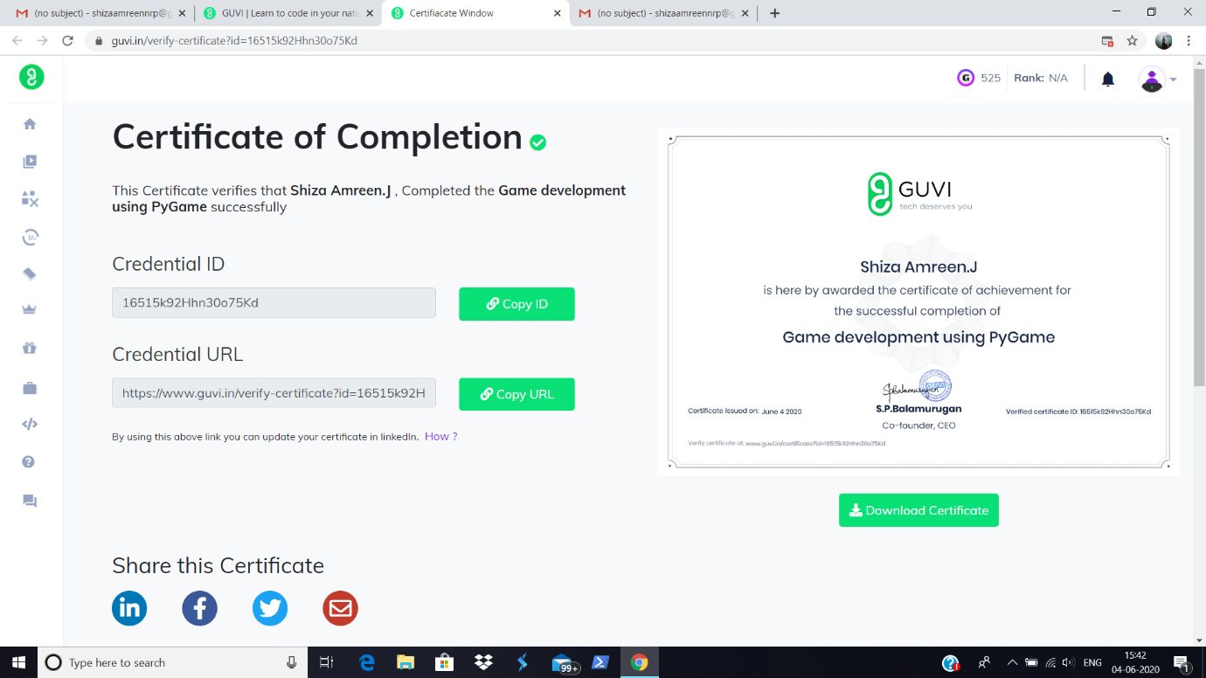

Certificate:

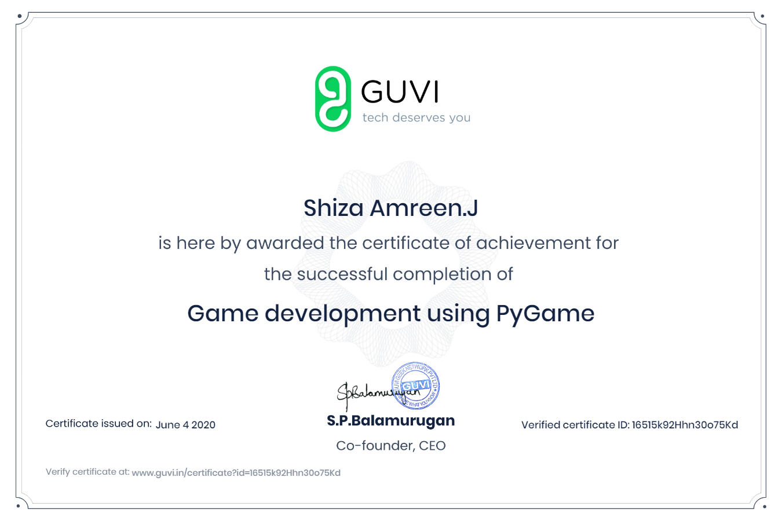

<https://www.guvi.in/verify-certificate?id=16515k92Hhn30o75Kd>

Coding Challenges Details:

|  |
| --- |
| **Problem Statement:**   1. **write a java program to read three integer values from the keyboard and find the sum of the values. Declare a variable "sum" of type int and store the result in it.** 2. [**Write a C++ program to find the missing number in array**](https://github.com/orgs/alvas-education-foundation/teams/2nd-year/discussions/99) |

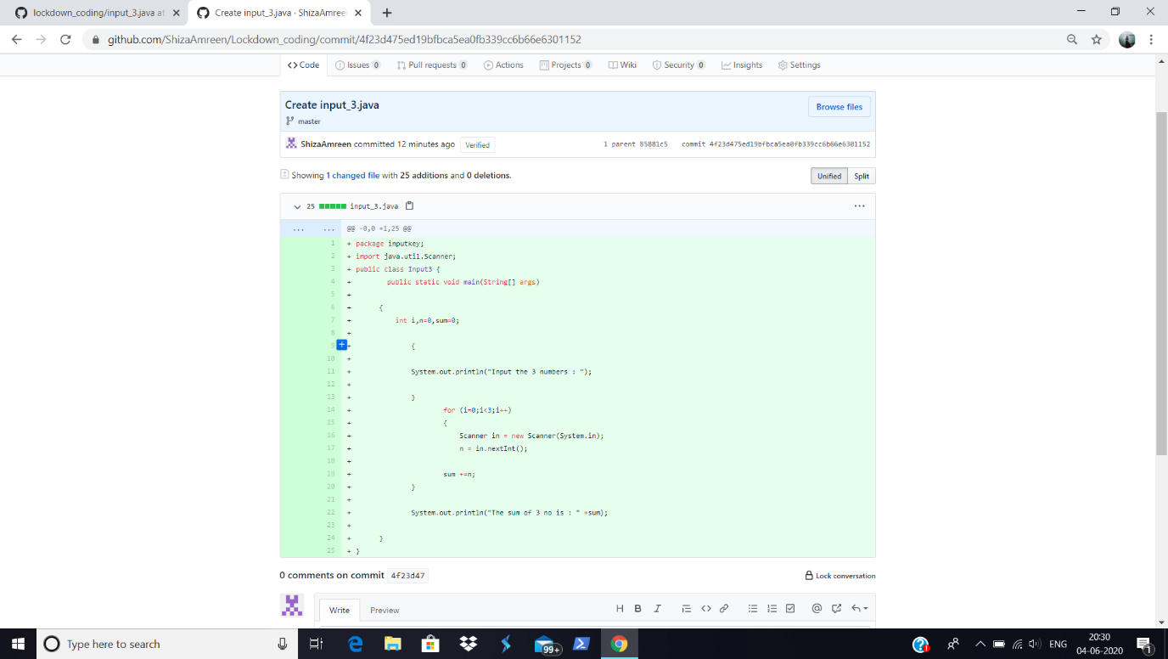

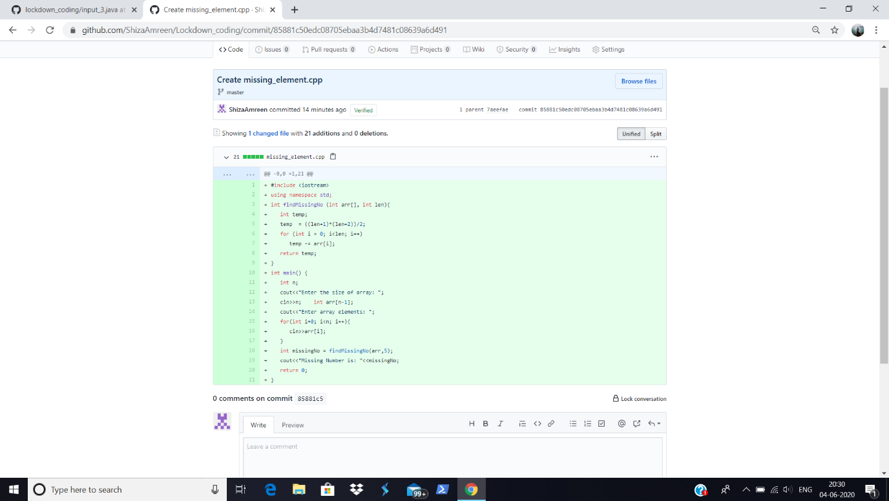

**I have written the code for above problem statements and uploaded it I my github repository, Lockdown_coding**.

<https://github.com/ShizaAmreen/Lockdown_coding/commit/4f23d475ed19bfbca5ea0fb339cc6b66e6301152>

<https://github.com/ShizaAmreen/Lockdown_coding/commit/85881c50edc08705ebaa3b4d7481c08639a6d491>